* **Data Loading and Data Modelling:**

1.Import the dataset into Power BI.

Step 1: Uploaded database into MySQL workbench.

Step 2: Establish connection between powerBI and MySQL workbench.

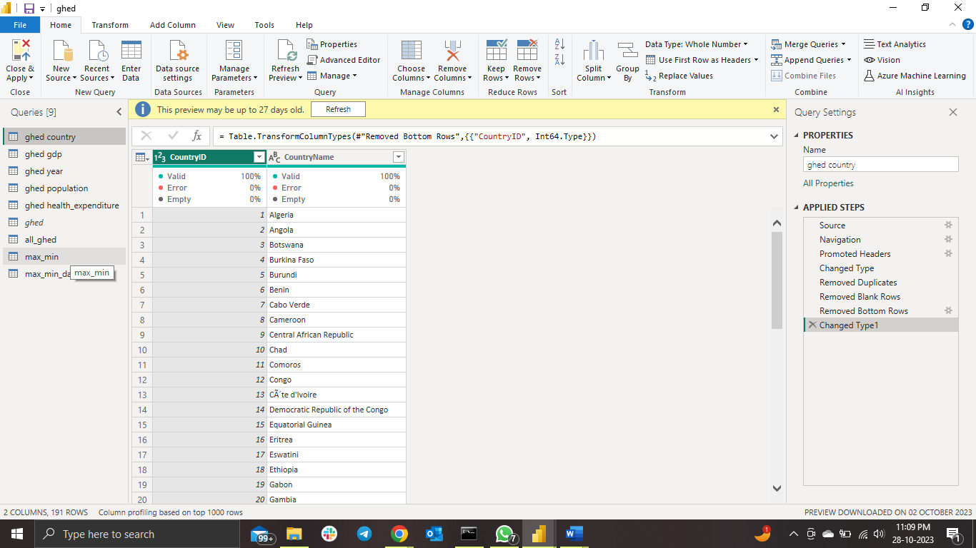

All tables import successfully.

2. Perform data cleaning and transformation as needed.

Used Power Query Editor for solving this problem.

Step 1: Clearly distinguish datatype of every feature.

Step 2: Removed null values and blank spaces from every table.

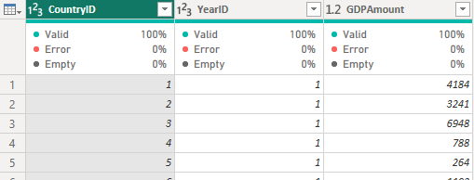

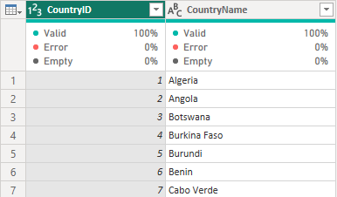

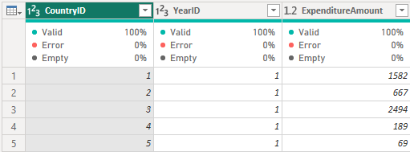?

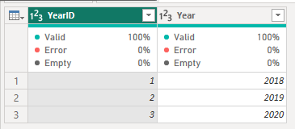

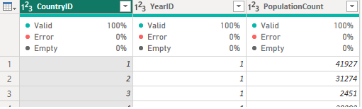

All tables uploaded and completed the cleaning process too.

3. Create a data model with appropriate relationships between tables (if multiple tables are used).

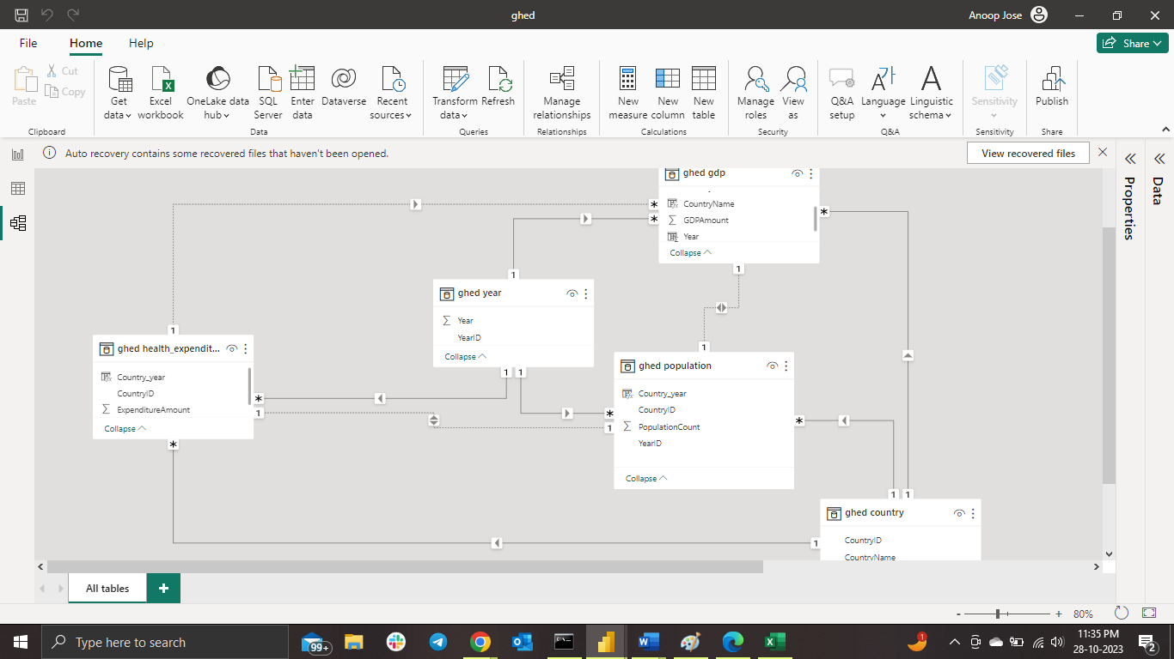

Created relationship between tables inside the database.

4. Ensure all relevant columns have appropriate data types.

Updated with appropriate datatype on every feature.

Refer above screen shorts for problem 2.

* **Data Analysis using DAX Functions:**

1.Create a new table that consolidates information from multiple tables using DAX.

New table created named ‘ghed_all’, from multiple tables information consolidated. Tried 2 different ways to solve.

* Using merge function on the Home tab.

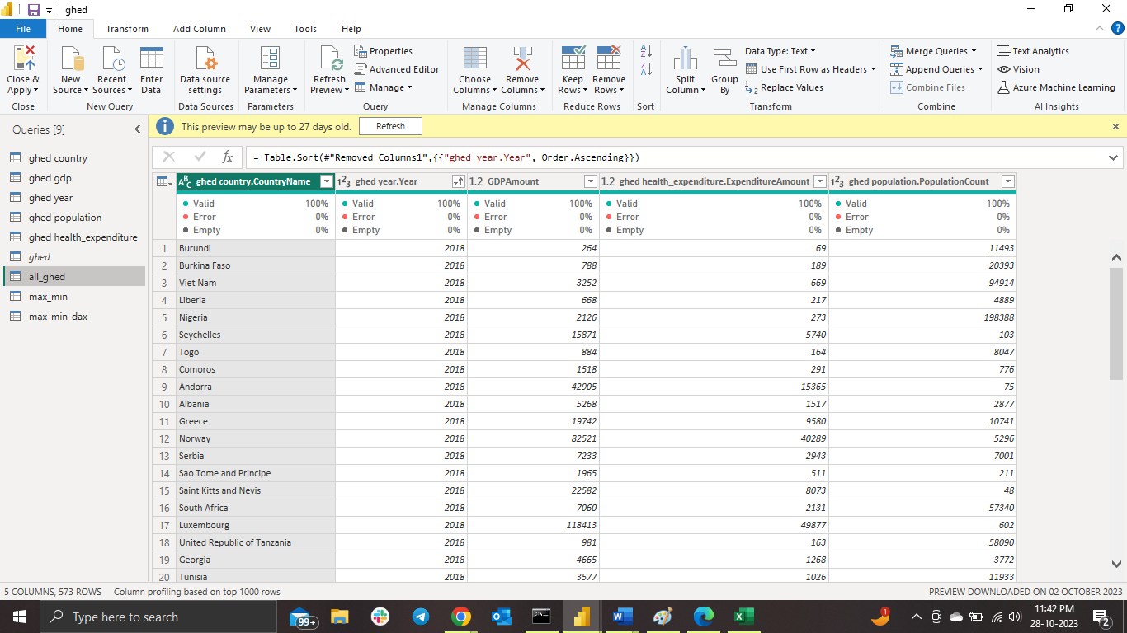

* Using DAX code.

HealthExpenditureSummary =

SUMMARIZE(

'ghed health_expenditure',

'ghed country'[CountryID],

'ghed year'[YearID],

"CountryName", MAX('ghed country'[CountryName]),

"Year", MAX('ghed year'[Year]),

"TotalExpenditure", SUM('ghed health_expenditure'[ExpenditureAmount]),

"TotalGDP", SUM('ghed gdp'[GDPAmount]),

"TotalPopulation", SUM('ghed population'[PopulationCount])

)

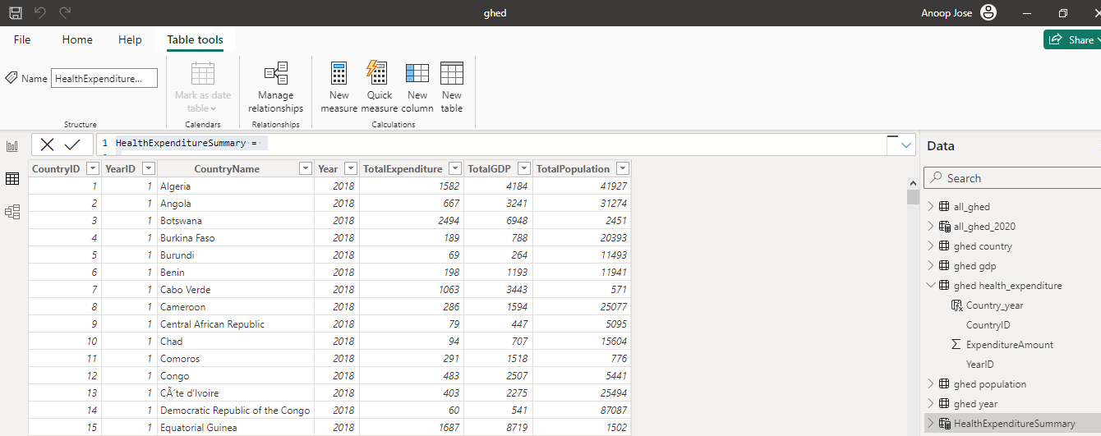

2. Find the countries/regions with the highest and lowest health expenditure for all years.

Nation with Max Expenditure =

VAR MaxExpenditure = MAXX(FILTER('HealthExpenditureSummary', 'HealthExpenditureSummary'[Year] = MAX('HealthExpenditureSummary'[Year])), 'HealthExpenditureSummary'[TotalExpenditure])

RETURN

CALCULATE(FIRSTNONBLANK('HealthExpenditureSummary'[CountryName], 1), 'HealthExpenditureSummary'[TotalExpenditure] = MaxExpenditure)

Nation with Min Expenditure =

VAR MinExpenditure = MINX(FILTER('HealthExpenditureSummary', HealthExpenditureSummary[Year] = MAX('HealthExpenditureSummary'[Year])), HealthExpenditureSummary[TotalExpenditure])

RETURN

CALCULATE(FIRSTNONBLANK('HealthExpenditureSummary'[CountryName], 1), HealthExpenditureSummary[TotalExpenditure] = MinExpenditure)

3. Determine the percentage of health expenditure as a share of GDP for each country.

Health Expenditure as Percentage of GDP =

DIVIDE(

    SUM(HealthExpenditureSummary[TotalExpenditure]),

    SUM(HealthExpenditureSummary[TotalGDP]),

    0

) * 100

4. Calculate the average health expenditure per capita for each country/region.

Average Health Expenditure per Capita =

DIVIDE(

    SUM(HealthExpenditureSummary[TotalExpenditure]),

    SUM(HealthExpenditureSummary[TotalPopulation]),

    0

)